Sanskrit Speech Sounds Unit

Lesson 1: Welcome!
Introduction

PREWORK: Before the first class, students should have completed the Learner Analysis [SEE P.10 OF TEACHER’S RESOURCE GUIDE] online as part of their first LMS module. Teacher will have some idea of students’ interests and background and can adjust/omit scripted discussion questions accordingly.

SING the English alphabet song and encourage the students to join in.

ASK: Do you remember when you learned that song? How old were you? Was it easy or hard to learn?

You are going to have the opportunity to learn the alphabet song in another language, a very ancient language. Just as you learned how to speak English before learning how to write, in this class you will learn the speech sounds of another language: Sanskrit. People in India have been speaking this language for thousands of years.

ASK: Has anyone ever done yoga? Can anyone show us a pose? [EVERYONE TRY POSE(S)]

Yoga poses have Sanskrit names. For examples, the word for Downward-Facing Dog pose is Adho Mukha Svanasana; Happy Baby Pose is Ananda Balasana, Child’s Pose is Balasana, and Tree Pose is Vrksasana.*

ASK: Have you ever heard Indian music or seen a Bollywood movie?

These media are primarily Hindi, which evolved from Sanskrit. After learning the Sanskrit alphabet, you may recognize some sounds in Indian music or movies. Hearing and vocalizing the sounds of the Sanskrit alphabet will also help you become more in tune with the sounds of English and recognize similarities between the two languages. You will also be able to feel the energy of these sounds, which is great fun! [TRY 5 different sounds and ask students which is more action-oriented, passive, kind, friendly, generous, etc.]

Learning Task

SHOW color-coded chart of all 48 sound symbols in horizontal lines without mouth diagram from Sanskrit by CD [P.6 OF TEACHER’S RESOURCE GUIDE].

ASK: Has anyone seen symbols like this before?

Each of these symbols is associated with a specific sound. You will recognize many of the same sounds in Sanskrit as in English, even though the symbols for them look very different from the letters you know.

SING just the vowel verse of the Sanskrit alphabet song [REFER TO P.15 OF TEACHER’S RESOURCE GUIDE (Foundation of Alphabet Song)]

The vowels that I sang are the foundation of the Sanskrit alphabet song, and each row of consonants is essentially a verse.

SHOW P.5 OF TEACHER’S RESOURCE GUIDE to demonstrate what students will learn in each lesson; SING Lesson 5 (Guttural) verse of song.

You will practice each of these sounds individually by listening to and watching recordings online outside of class. All of the visuals I show you in class are also housed on our class LMS. You will record yourself practicing the sounds in our interactive forums, I will review those recordings before we meet again, and then we will practice and refine your pronunciation together in class. At the end of this unit, you will be able to sing the Sanskrit alphabet song along with me and make an accurate recording of it on your own!

Learning Process

Besides a symbol, each sound is associated with a certain position of the mouth.

SHOW color-coded chart of all 48 sound symbols in diagonal lines with mouth diagram from Sanskrit by CD [P.7 OF TEACHER’S RESOURCE GUIDE].

SHOW animated mouth diagram (linked from LMS): 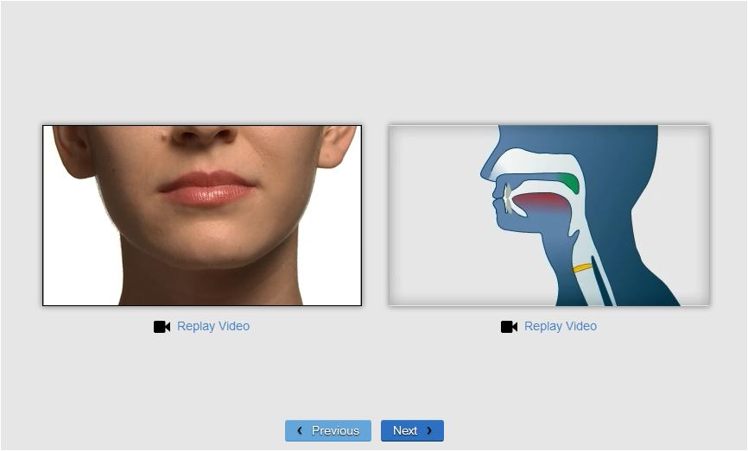
Example (different sound) from LANGUAGE! Live: http://www.voyagersopris.com/info/languagelive-demo/level1_demo/Cambium/Runway/Demo.html#6

HAND OUT a small children’s mirror to each student.

We will practice making each sound individually by moving our mouth, tongues, and lips in specific ways. For instance, look in your mirror as you say the first pink letter in Row 4 (ta). Repeat after me. Can you see your tongue? Where is it? Why do you think we would call the letters in this row “Dental”? [TONGUE AT TEETH]

Now look in your mirror again as you say the pink letter in Row 5 (pa). Repeat after me. What do you notice about how you are making the sound? [LIPS] That is why we call this row “Labial.”

On our class LMS, there are excellent diagrams of what’s going on in your mouth when you make these sounds. There are also tutorials that you will watch and recordings that you will listen to at home to practice proper pronunciation.

SHOW example of online tutorial (different sound) from LANGUAGE! Live: http://www.voyagersopris.com/info/languagelive-demo/Dashboard.html

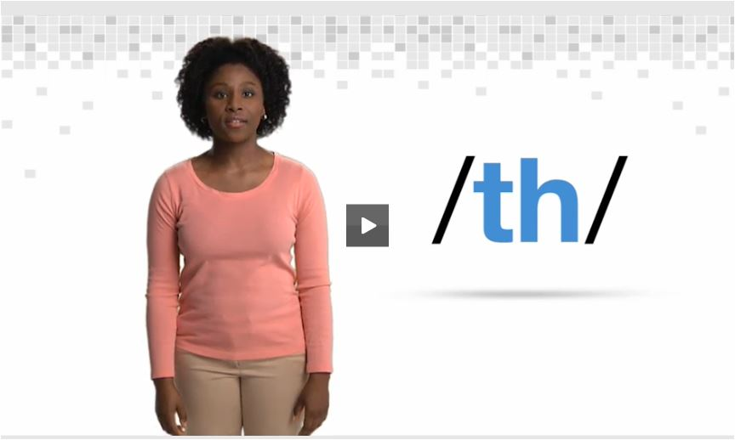

Conclusion

So, that is what we’ll be doing in this unit. We’ll take it one sound at a time until we learn the whole Sanskrit alphabet song.

ASK: Now that you have been introduced to the Sanskrit language, what can you tell me about it? What struck you as something interesting that you will want to share with a parent or friend?

Congratulations on already learning something that not many people know! This is just the first step in learning the oldest language in the world! In our next lesson we will learn the simple vowel sounds and how to correctly pronounce each sound by moving our mouths in specific ways.

Home Study

At home, listen to the recordings on the web page for this module (Tracks 1 through 3 on Disc 1 of Sanskrit by CD). Record yourself pronouncing the sounds you hear and post your recordings in the online forum. I will provide quick feedback on anything you share in the forum, and you can also give feedback to your classmates. Then we will review at the start of next class and work through any problems you may have encountered. As they say, practice makes perfect!

Please also watch this video, located in our first module online, for a very brief history of Sansrkit: http://youtu.be/YLVY66bzhzs

*Yoga pose references:
http://yoga.about.com/od/yogaposenamesinsanskrit/
http://www.yogajournal.com/lifestyle/159

